**Gabitt driver iOS bug report:**

**Sign up testing:**

1. The image size should be 1:1 means that the user should be able to upload the full size image and then should be able to crop it.
2. There is no option to upload the profile picture through “Files”, “Photos” and other locations from the phone.
3. If a user clicks on the verify button without entering verification code than the timer will start working very fast. If the user again clicks on verify button than the timer will work faster. (It continues to happen for both “verify” and “resend” buttons.
4. Make vehicle color field mandatory. (Vehicle Color is not displaying on Admin Panel). Ask the color field parameters from “Iqbal” for it.
5. Hide the following documents for now:

a)Driving license back

b) Police clearance certificate

c) Witness 2 cnic front

d) Witness 2 cnic back

6. The user should also be able to select documents from “Files”, “Photos” and from other phone locations.

7. In bank detail the “Account Number” field length could be 16 or less. It is set to “13” right now.

8. Note that bank detail form is optional. If the user doesn’t fill the “Bank Details” and click on sign up button than he is not allowed to move forward. If the bank details form is not filled still the user must be moved to the next screen which is “Terms and Conditions Agreement”

9. Replace the word “Qarbook” with “Gabitt” throughout the app.

10. The “Terms and conditions agreement” is old one. Replace it with the new one. (Ask “Akshay” for it’s API).

11. Insert the correct length and data type validation for “License No” field as mentioned in “SRS Document”.(Fragment 1)

12. The “license no” entered on the sign up is displaying in the “Postal Code” field on the panel. It should be displayed in the “license no” field + wrong CNIC NO is displaying in “CNIC” field on the panel i.e it is not one that I’ve entered on sign up + wrong “license no” is displaying . (Ask iqbal for keys of the fields on the admin panel)

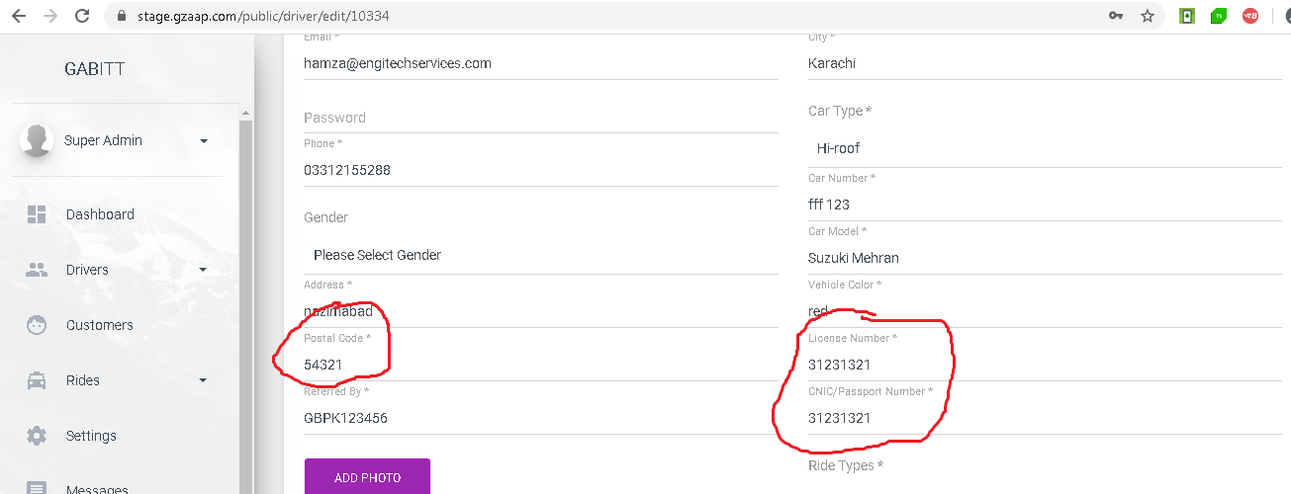

**Driver Profile:**

1. Remove the setting icon from the picture. The driver picture is not editable
2. Display the driver’s referral code in a button displaying his referral code below the circle car button and on clicking on the referral code button, it can be shared on whatsapp, messenger or private message etc

**Basic Details Section:**

1. Full email address is not showing in “Basic Details”
2. Wrong “Passport No” and “License No” are displaying.
3. The “License No” is showing in the “Postal Code” field.
4. Correct the “Postal code” spelling and change it from “Post Code” to “Postal Code”

**Car Details:**

1. Change “Vehicle Make” to “Vehicle Name”
2. Show “Vehicle Color” field
3. Replace the keys of fields “Car Type” and “Vehicle Name”. The car type’s data is displaying in the vehicle name field and vehicle name is displaying in car type.
4. The “vehicle color” field data is not showing.

**“Share “ option in menu list:**

Add a “Share” option in drawer. When the user clicks on “Share” than he can share the app store app installation link to others.

**Ride request not coming:**

The car is displaying on the map at passenger’s app but ride request is not coming at the driver’s app.

**Rating:**

The full heading “Rating” in the Rating section is not visible.

**Documents:**

Align the “Document Details” heading in the center in the “Documents” section.

**Invoices:**

1. Add Rs. before the value in “with draw” and “Deposit” sections
2. Different amounts are showing in “Total Drawable Amount” and “Total Amount”. The same amounts should be displayed.
3. Add “Rs.” before amount in summary.

Note: The images related to “Invoices” section have been uploaded on “Trello” with the card name “Invoices section in driver app”. Take help from it for understanding the flow and design.

**Ride:**

1. Change the ride acceptance time from 20 to 30 sec
2. Add a ride cancel option with the arrive button after accepting the ride. The driver has two options:

a)Arrived ( Red color button) (Also change the “Arrive” spelling to “Arrived”)

b)Cancel (After selecting “Cancel” option, a dialog box will appear having the options as 1. Drop off too far 2. VIP Movement and 3. Vehicle Breakdown. The user should be able to select any from these options and after clicking on “Ok” the accepted trip request should be cancelled by the driver and at the same time, the selected message must be displayed at the passenger’s end)

3. On clicking on “Start Ride” button add a confirmation dialog, “Do you want to start ride” with two options “Cancel” and “Ok” and do same for “End Ride”.

4. On the “Start Ride” screen a timer should be opened for 5 min, if the passenger didn’t arrive in this time than a popup should open having two options “Wait more” and “Cancel”, if the user selects wait more than again a timer of 5 mins should be started. Currently on clicking on “Wait More” the timer is of “30 sec”. Every time the user clicks on “Wait More”, a timer of “5 mins” should be started.

5. During a ride if the driver closes the app, then the app should also run in background and after opening the app, it should continue from the same point.

6. During a ride means after starting a ride, the “Ride tracking” heading is not properly visible.

**Ride flow screen shots:**



